AFEA Version 4 FIXED: 7-9-2015

1. **Chapter Dashboard**
   1. **Manage Your Messages** 
      1. **why is there a always there next to New Messages? Does this number change when there are actually new messages?**
      2. **Differentiate between “New Messages” and “All Messages” instead of showing the same ones for both. New messages should just be messages that have not been read. All Messages is where read messages are displayed until they are deleted**
      3. **Send Messages – Doesn’t allow proper text input in the message box once you select a certain trainee**
   2. **Edit Profile** 
      1. **Change Retypepassword to Re-type Password**
   3. **MY CHAPTER** 
      1. **Make this say “VIEW MY CHAPTER”**
      2. **Make it a Green Button**
      3. **Layout**
      4. **Clean up layout so Chapter President’s information box matches the same size as the Video box**
      5. **Edit Presidents Column**
      6. **Fix Layout so that the boxes always match in size and display. The Edit Message links can be used to open and view all.**
      7. **When changes are made and saved the box needs to close and the page needs to update/refresh itself**
      8. **A message should be displayed that says: Your changes have been saved successfully.**
   4. **SPONSORED SCHOOLS & CHARITIES**
      1. **Need a Featured Button to determine which charity is feature on the chapter page**
      2. **Maximum number of featured charities is three**
      3. **Fix Layout to maintain same spacing for text box and pictures regardless of the amount of content – use a read more to expand the description**
   5. **MANAGING BOARD OF DIRECTORS**
      1. **Change heading to: MANAGAGE MY CHAPTER BOARD OF DIRECTORS**
   6. **PREFERENCES & SETTINGS**
      1. **NEWS**
         1. **Change Icon from NEWS to: Chapter News**
         2. **When Clicked on, heading should say: “Chapter News” instead of just “News”**
         3. **Click on ADD NEWS button**
            1. **Title of Pop Up should be: “ADD CHAPTER NEWS” instead of “ADD A NEW NEWS”**
            2. **Choose File – should be: “Upload Picture”**

**Auto adjust picture size to keep formatting**

* + - * 1. **News Date format should be displayed: dd/mm/yyyy with this as an example of how to input it correctly**
  1. **SPONSORS**
     1. **SPONSORS icon** 
        1. **Should say: “Chapter Sponsors”**
     2. **Click ADD SPONSOR BUTTON**
        1. **Choose File should be: Upload Logo**
        2. **Give more space between the link field**
        3. **Change wording from “Link” to say: Insert hyperlink Here**
        4. **Change Save Sponsor to Submit Sponsor**
           1. **Submitting sponsor will notify admin**
           2. **Admin will have the ability to approve the sponsor**
        5. **Need a button on the form to select if the Sponsor is featured. If selected the Sponsor will show up on the Featured Sponsors list on the Home page as well as on the Chapter Page**
        6. **Remaining Sponsors should be displayed using a “View ALL Sponsors” button.**

1. **Chapter Page**
   1. **We need to Add a Center Caption on the Chapter Picture:**
      1. **“The Path To Your Financial Success Starts Here!”**
      2. **Add a: “Register for Upcoming Classes” button right below that Caption**
         1. **Clicking the button sends the user directly to view ALL of the Chapters Upcoming Classes**
   2. **Move the Address box a little more to the left corner to make room for the Caption**
   3. **Sponsored Schools Icon on Navigation Bar**
      1. **This is out of order – should come after Chapter Directors icon**
   4. **PRESIDENT’s COLUMN**
      1. **Layout – Do not wrap the text around the Chapter President’s info Box. Just use one column with a maximum amount of characters displayed to maintin the formatting. Use a Read More button to open to another page with fully expanded Message**
      2. **Keep the Presidents Message the same size as the video box for uniformity on the page**
   5. **NEWS & EVENTS**
      1. **SIGN UP FOR UPCOMING CLASSES**
         1. **Change to: REGISTER FOR UPCOMING CLASSES**
         2. **This will open to a page with all of the Chapters Upcoming Classes (No need to just capture their information on a form unless they are registering for an actual class)**
      2. **Upcoming Events - Read More – Expanded Version of event**
         1. **START LEARNING button**
            1. **This should open a Training Video**
         2. **ADD – below the START LEARNING button a “REGISTER NOW” button**
            1. **This button will take the user to the registration form**
         3. **ADD- Special Instructions in the Grey Box underneath the “Location”**
         4. **Registration Form**
            1. **Use the Same Registration form that we currently have to register students for classes: (See Below)**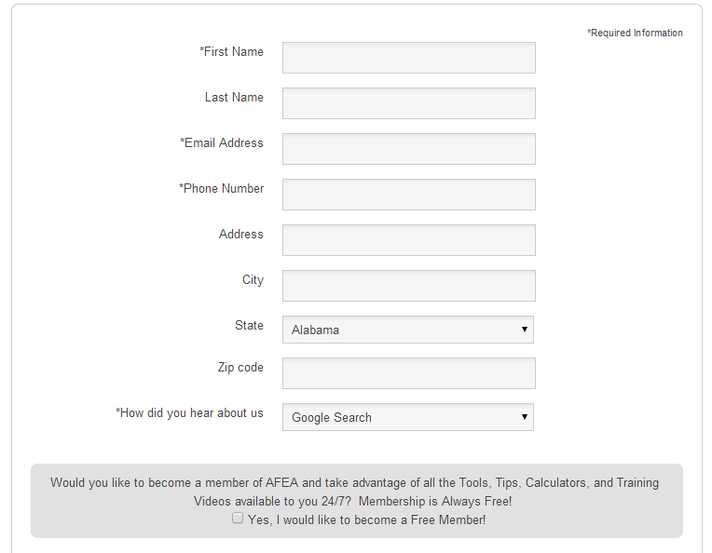
            2. **ADD the following Field to the above form**

**Will You Be Bringing Someone? YES I NO (Clickable)**

**If YES then expand to: Add Guest Info:**

**First Name**

**Last Name**

* + 1. **View Event Calendar**
       1. **Clicking on a displayed event below the calendar does not expand it to the event description page**
    2. **Chapter News Headlines**
       1. **Links do not work**
  1. **CHAPTER DIRECTORS**
     1. **Change “Join Our Chapter Directors” to: “Join Our Chapter Board of Directors”**
     2. **Change Picture to the following:**
     3. 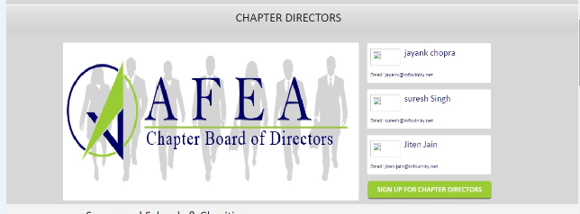
     4. **Change the “JOIN AFEA” button to “APPLY NOW”**
        1. **The APPLY NOW button will take people to the application form**
     5. **Change “SIGN UP FOR CHAPTER DIRECTORS” to: “VIEW OUR BOARD”**
        1. **The VIEW OUR BOARD button will take the user to a page where all of the Chapter Directors are displayed with their pictures and brief Bios.**
        2. **They Each will have a Contact Me button under their picture**
        3. **The Chapter President will be on Top**
        4. **Each Position will have a Read More button that opens a Pop Up that displays more of their detailed information**
  2. **SPONSORED SCHOOL & CHARITIES**
     1. **This should be a Section Header**
     2. **Needs Explanation Content**
     3. **Up to Three Featured Schools & Charities should be displayed on the Chapter Page.**
        1. **The featured ones would be chosen by the Chapter President when adding them to the chapter**
  3. SUPPORT OUR CAUSE
     1. Needs explanation Text
     2. Needs Place Holder for a Video
     3. Add a “LEARN MORE” button
        1. The LEARN MORE button takes the user to a full description page
        2. This page is where you will find the PayPal Donate Button
     4. Display Featured Chapter Sponsors within this section
        1. The LEARN MORE button page will also display all of the Chapters Current Sponsors
  4. **WHY JOIN AFEA**
  5. **Need a New Picture – Get rid of the little kid hands. Something like this:**

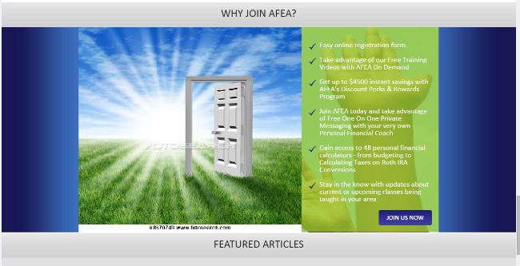

* + - 1. **ADD CAPTION – “The Path to Your Success Starts Here!”**
  1. **FEATURED ARTICLES**
     1. **Remove from Chapter Pages. No need to have this here. It should only be displayed on the home page**