**Chapter Dash Board– Updates 5/07/2015**

1. **Coach ID**
   1. **This should be changed now to Chapter ID – per this upgrade all coaches, sub-agents, chapter directors, and trainees will be assigned to a chapter**
   2. **Each Chapter will have its own ID**
      1. **This way we capture trainees in each chapter and they are not attached to the coaches id in case the coach leaves**
2. **Edit Video**
3. **Needs to have instructions so user knows what to do:**
4. **Insert Embed Code Here**
5. **Paste Video Link Here**
6. **Need ability to add an image to display for the video**
7. **Youtube videos do not seem to have a way to add the image**
8. **Need a confirmation that the video has been saved successfully when you hit the save button**
9. **Messages** 
   1. **Delete Message does not work properly. Takes user to video screen**
10. **Presidents Message**
    1. **Presidents is misspelled in the Navigation Bar** 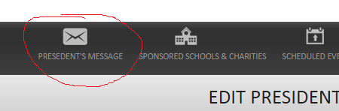
11. **Sponsored Schools & Charities**
    1. **Need a Content Text Box Editor to be able to add text content to display on the chapter page above the list of Sponsored Schools & Charities**
    2. **Change wording on button to Add Schools & Charities** 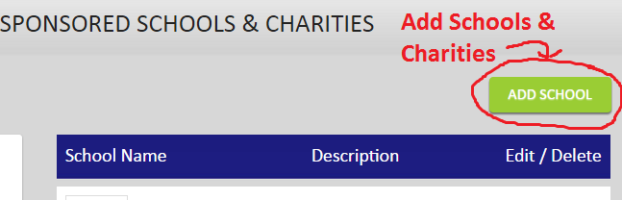
    3. Input Pop Up Page Errors –
       1. 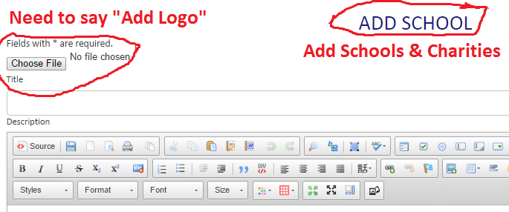
    4. Donation Thermometer – Still need to add donation option.
    5. **Need a verification that the New School or Charitiy has been successfully saved and the pop up window should then close and return the user back to their chapter dashboard**
    6. **Newly Saved Schools & Charities are not displaying on the Chapter Page**
    7. **View More Link (Schools & Charities)**
       1. **Change title to: Sponsored Schools & Charities**
       2. **Make ‘View My Chapter’ a Bigger Button**
       3. 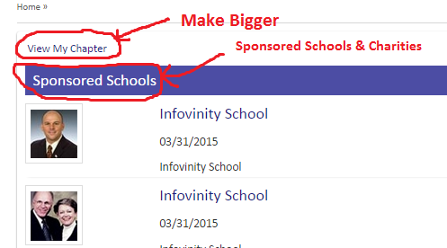
    8. Donation Thermometer Functional?
    9. **This section should not be able to be closed on the chapter page by hitting an “X”**
12. **ADD Scheduled Events**
    1. **Label Upcoming Events section – Move this down to the same line as the Add Event Button** 
       1. 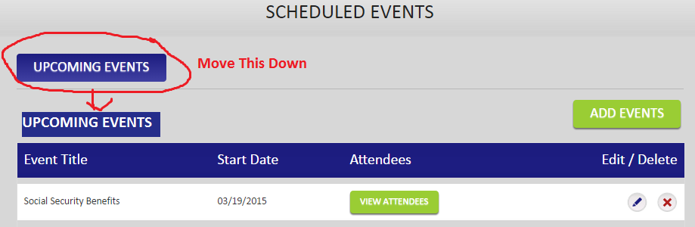
    2. Need to be able to Export Attendees to Excel Spreadsheet (This is a Current Feature that is missing) 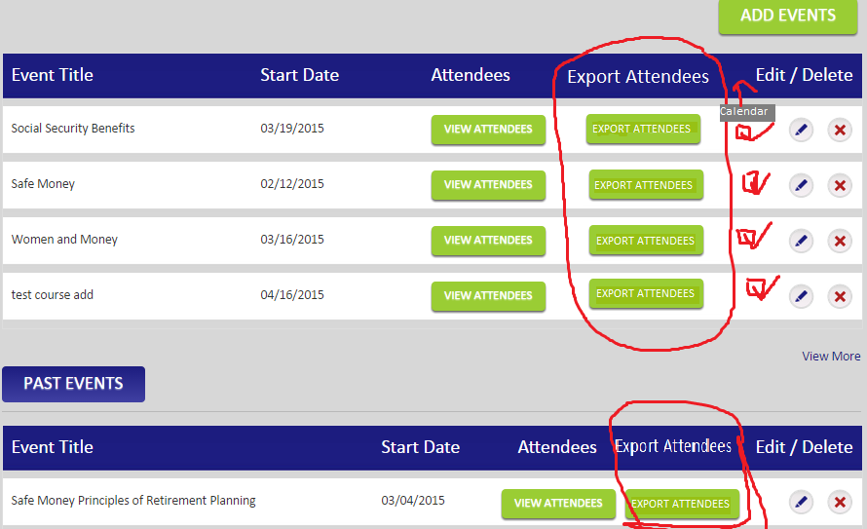
    3. **Also need the Calendar notification that is currently on our site to show if the event was posted on the calendar**
    4. **Need to make the following changes to ADD Event:**
       1. 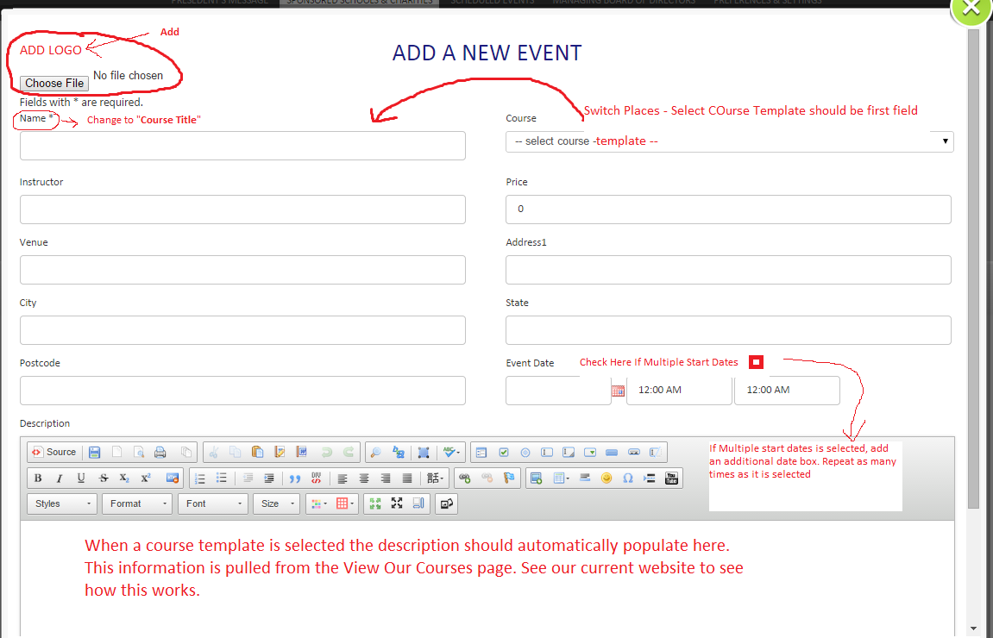
       2. **Course Start Time & End Time fields need to be labeled**
       3. **Add a box that says “Check Here if Multiple Start Dates ” – if this is selected add an additional field for date and times. Repeat this as many times as they select the box for multiple dates**
    5. **Allow Admin to Set a minimum price for certain courses in the admin panel**
       1. **If a minimum price is imposed by the admin for a specific course do not allow the user to input a number lower than the minimum price set by the admin**
    6. **Course Title is only needed if the user selects “Other” from the drop down list where there is no template. They will then have to create their description as well. (See existing website feature)**
    7. **State – this should be a drop down of the fifty United States**
    8. **Logo – Logo should display the workbook image if a Course Template is chosen otherwise leave blank unless the user uploads a logo file (See Existing Website Feature)**
    9. **Tab button on keyboard - This does not work properly when inputting data into the Pop Up ADD EVENT fields.**
    10. **Need to add the following missing features to the Input Pop Up Add Event Page** (See existing website add event form):
        1. 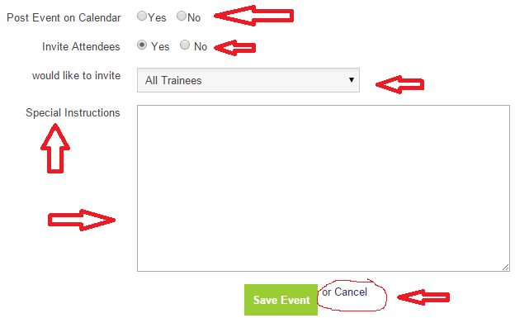
    11. **Add a field to input “Room Number” (Not a required field)**
    12. **Course Templates not populating in description fields**
    13. **Newly added events not displaying on Chapter Page**
13. **Managing Chapter Board of Directors**
    1. **Add “Upload Profile Picture” option to allow user to upload a picture of the new board member**
    2. **Add Text Editor Box at bottom so user can add Bio Information for the new board member**
    3. **Change “Course” drop down to “Board Position” and use the following options. The option chosen will display as the Board Member’s Title underneath their profile picture**
       1. **CPA/ Accountant**
       2. **Attorney**
       3. **Proper & Casualty Specialist**
       4. **Mortgage Specialist**
       5. **Real Estate Agent / Broker**
       6. **Health Insurance Specialist**
       7. **Financial Advisor**
       8. **Insurance Specialist**
       9. **Executive Assistant / Admin**
    4. **There are no limits to how many board members a chapter can have**
    5. **Chapter president can only fill out the form and submit it for approval**
    6. **Once the form is filled out it will be saved as pending, and the admin will be notified of the request. The admin will be able to look over the saved profile and approve it or decline it. If approved the profile will become active and the board member will be displayed on the chapter page** and gain access to all permissions they have been given by the chapter president. If declined the chapter president will be notified via a message that says: “Sorry this application has been denied. Please contact home office for more information.”
    7. Chapter Board of Director members will need the ability to send and receive messages from trainees assigned to the chapter- this will need to be added as a permission
    8. Admin must approve before the Chapter Director becomes active
    9. Chapter President will need the ability to send messages to Chapter Directors
    10. Chapter Directors will display on the Chapter Page as a Picture with their position and a “contact me” button (do not show their email addresses)
    11. If a user clicks on their name it will open and display their Biography with a video of them speaking.
14. Tools & Resources
    1. Need a way to get back to the Chapter Dashboard after viewing without having to click the Back Browser button so many times. It would be nice to have a “Back to Dashboard” button at the top of every page once a user leaves the dashboard that takes them back to the dashboard.
15. My Trainees
    1. This button currently takes the user to the Messages Page. It should take the user to a list of all trainees assigned to the Chapter. There will need to be a Search bar and an alphabet at the top of the page so that the user can find a trainee easily without having to scroll through a large list.(we are working on search bar)
16. Training Videos
    1. Chapter President will not have the ability to edit Training Videos that the admin posts as mandatory
    2. Chapter President can add other training videos to their Chapter Page if they choose. These should be separated by the following categories:
       1. Mandatory Home Office Training Videos
       2. Chapter Training Videos